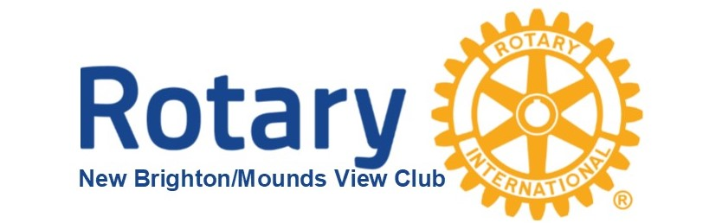

2022 Gold Plate Dinner Fundraiser
“No Plate” Option
$200.00 Raffle Prize*

Unable to join us for our Gold Plate Dinner Fundraiser on April 22, 2022?
You can still partner with us to support our community!

$_______ Payable by check to NB/MV Rotary (any amount)

$_______ My purchase of raffle tickets* at $50.00 each
(need to receive funds by 4/20/22;
Drawing will be on 4/22/22)

$_______ Donation payable to Rotary Healthy Youth Foundation
(a 501c3; tax deductible)

Please either mail your check(s) to:
NB/MV Rotary
PO Box 120284
New Brighton, MN 55112

OR:
Donate online via https: https://donorbox.org/support-rotary
*If you would like to leave your name, please do in the comments

Questions?: Please call Mary at 651-442-6891

THANK YOU FOR YOUR SUPPORT

